Final Hands-On Project
Build a complete ETL pipeline:

Scenario
Sales company receives daily files.
Source
CSV Files

Destination
Sales Data Warehouse

Pipeline Steps
1 Load CSV files
2 Clean data
3 Remove duplicates
4 Transform columns
5 Load into warehouse
6 Log errors
7 Archive processed files
Source
CSV Files containing sales transaction data.
Columns in the CSV file:
- OrderID
- CustomerName
- Product
- Quantity
- Price
- SaleDate

Destination
Sales Data Warehouse (SQL Server Table)

Control Flow Implementation

1. Foreach Loop Container – Load CSV Files
The Foreach Loop Container is used to iterate through all CSV files in the input folder.

Configuration
Enumerator :Foreach File Enumerator
Folder :Input folder containing CSV files
Files : *.csv
Retrieve File Name : :Fully qualified file name

Variable Mapping
Variable used: : User::FileName
This variable stores the file path of the current CSV file being processed.

2. Data Flow Task
The Data Flow Task processes the content of each CSV file.
Operations performed in Data Flow:
- Read CSV file
- Clean data
- Remove duplicates
- Validate rows
- Load valid rows into database
- Log invalid rows
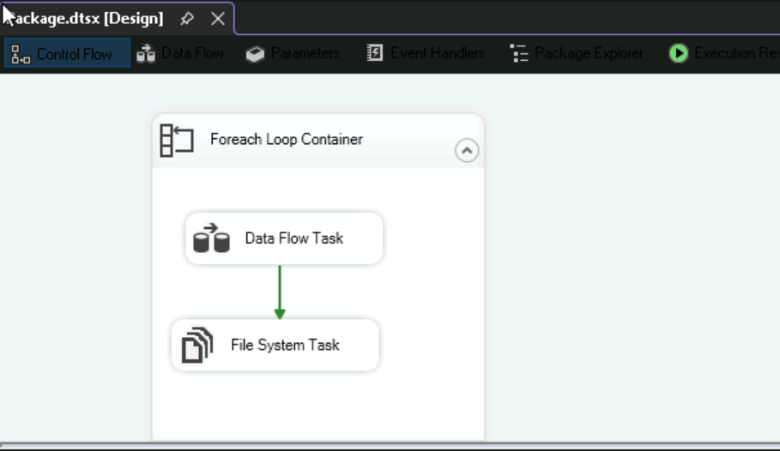

Data Flow Components

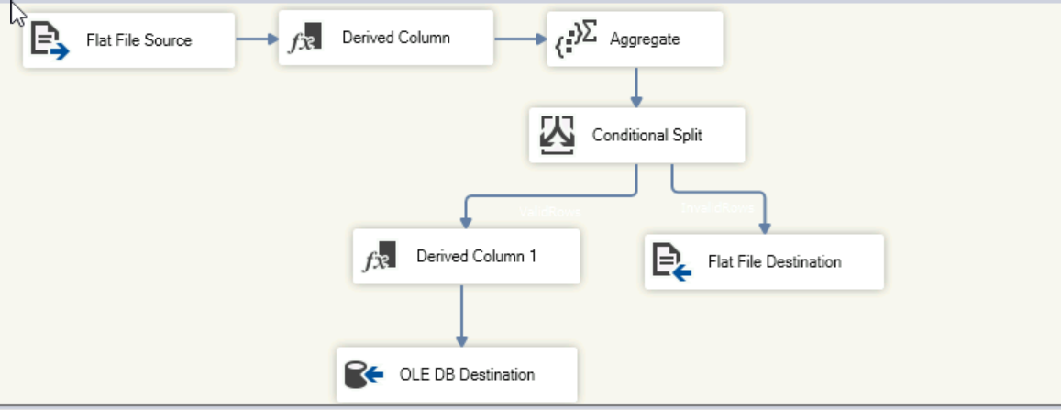

2.1 Flat File Source
Reads the CSV file passed from the Foreach Loop.

Configuration
Connection Manager: Flat File Connection Manager
File path : Uses variable expression
User::FileName

2.2 Derived Column – Data Cleaning
The Derived Column Transformation is used to clean the data.

Transformations performed
Remove extra spaces using TRIM.

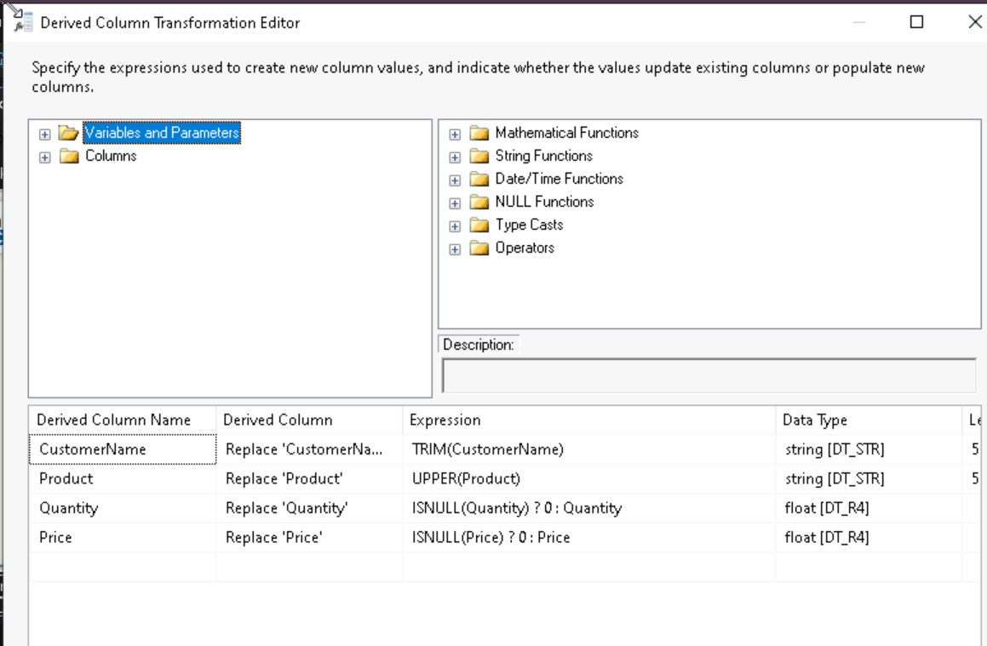

2.3 Aggregate Transformation – Remove Duplicates
The Aggregate Transformation is used to remove duplicate records.

Configuration
Group By columns:
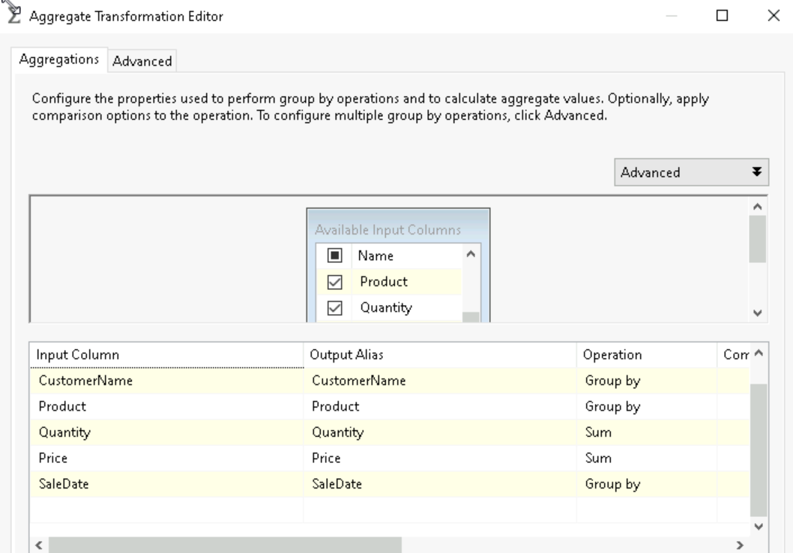

2.4 Conditional Split – Data Validation
The Conditional Split Transformation separates valid rows and invalid rows.

Conditions
ValidRows
Quantity> 0 && price> 0
InvalidRows
Quantity<= 0 || price<= 0

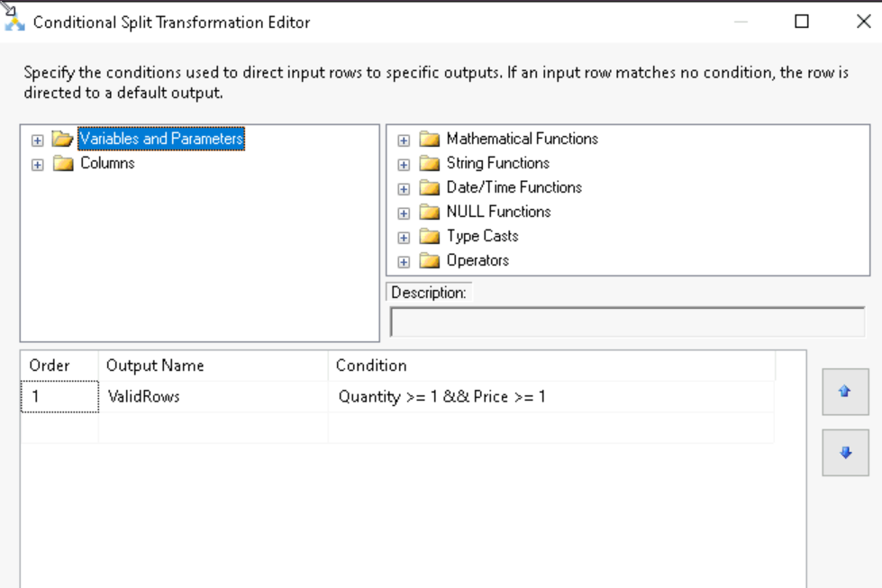

Handling Invalid Rows

Flat File Destination – Error File
Invalid rows are sent to a Flat File Destination.

Output File : InvalidRows.csv

Handling Valid Rows

Derived Column 1 – Data Transformation
Another Derived Column Transformation is used to transform columns before loading to the database.
Calculated total amount=price*quantity then add as new column
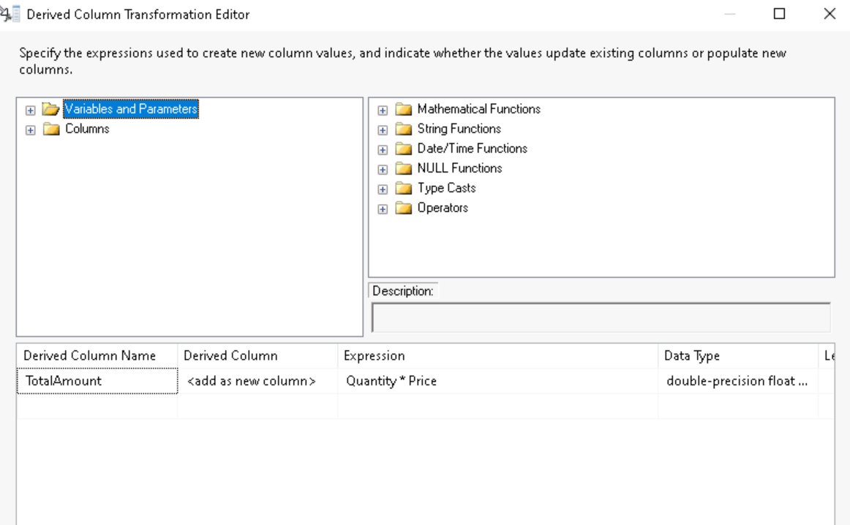

OLE DB Destination – Load into Warehouse
The OLE DB Destination loads the processed records into the Sales Data Warehouse.

Configuration
Connection : OLE DB Connection Manager
Destination Table : Sales warehouse table
Column Mapping : Source columns mapped to database columns
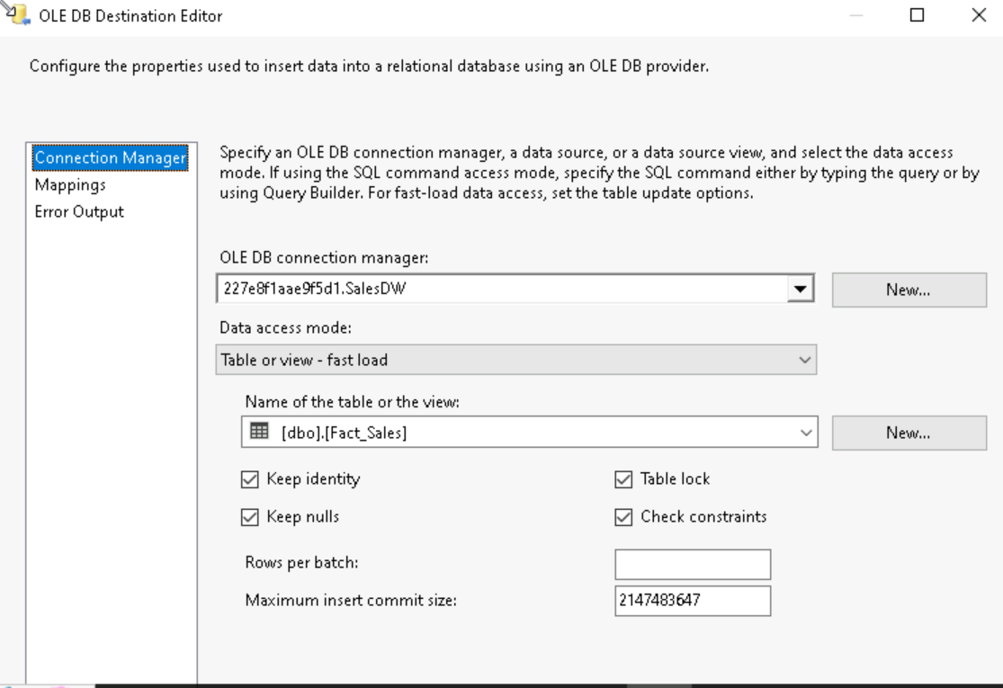

3. File System Task – Archive Processed Files
After the Data Flow completes successfully, the File System Task moves the processed file to an archive folder.

Configuration
Operation : Move File
Source Connection : Input CSV file
Destination Connection :Archive folder
